# CHAPTER THREE: RESEARCH DESIGN AND METHODOLOGY

## 3.0 Introduction

In this chapter, the locality of the project, project beneficiaries, research design approach, sampling, data collection methods, data analysis and testing the plan for the system shall be discussed.

## 3.1 Locality of the project and Beneficiaries to the project

This system will be implemented in Nairobi, Kenya and will be made available to small scale urban farmers and gardeners within the city. The beneficiaries of this project are local farmers and gardeners within the city of Nairobi. By using this system, the farmers and gardeners will monitor the soil moisture and the amount of water that is flowing to their respective farms or gardens.

## 3.2 Research Design approach

According to Cresswell, “research design is a model or an action plan upon which the entire study is built; dictates the manner in which a study is conducted and provides the road map of a study in terms of the sample, data collection instruments and analysis procedure.” (Cresswell, 2003)

The research design aimed at this project is descriptive research design that aims to accurately and systematically describe a population. This project also employs mixed methods of data collection. Data is collected quantitatively and qualitatively to triangulate the data. The qualitative aspect of the project is done through short interviews mainly open-ended behavior based questions whereas the quantitative data shall be done through questionnaires. In addition, both primary and secondary data will be utilized to collect adequate data about this project.

## 3.3 Population of the study (Target group) and Sampling method

A sample refers to the target population for a survey which is the entire set of units for which the survey data are to be used to make inferences. For this research, the target group are urban farmers and small garden owners.

According to Foekan et al. “The majority of the urban farmers in Nairobi are women and about 25% of the population of Nairobi is engaged in urban farming.” (Foeke, 2008)

. The sampling method for this project is systematic sampling, which is a probability sampling where a target population is selected.

## 3.4 Data collection methods and Primary Data collection methods

### 3.4.1 Primary Data Collection Methods

**Online questionnaires**

These methods involve data that is collected for the first time. For the proposed system, interviews and observation methods were done. Due to the COVID-19 situation, the main primary data collection for this project is online questionnaires. The online questionnaire will consist of both open-ended, and closed-ended questions. With the use of google forms, I will send this online questionnaire to the target group then later collect, gather and analyze the data through graphs.

### 3.4.2 Secondary Data Collection Methods

These methods consist of data that has already been collected by someone else and passed through a statistical process. The main source of secondary data for this project due to the COVID-19 situation is the internet. In addition, other sources of information such as books, and journals will be used as reference to gather adequate information.

## 3.5 Data analysis methods

Both qualitative and quantitative data analysis will be used for this project. In terms of quantitative analysis, any numerical data will be analyzed with the use of graphs and pie charts. For the qualitative aspect of this research, data will be represented through pictures that explore the data in a visual way.

## 3.6 System analysis and design methods

For this project, the system development life cycle choice is the waterfall development methodology. This methodology is a sequential software development process, where progress flows steadily toward the conclusion (like a waterfall) through the phases of a project (that is, analysis, design, development, testing). This involves fully documenting a project in advance, including the user interface, user stories, and all the features’ variations and outcomes.

One of the strengths of using this methodology is that it determines the goal clearly through progresses that are flowing steadily. Furthermore, documentation of each development stage provides resistance to changes in human resources thus allowing a new developer to quickly get all the necessary information. The sequential phases in the waterfall model are:

* **Requirement Gathering and analysis:** To achieve this, I have gathered and identified all the necessary information, hardware components, software applications and other tools necessary for the development of this project. E.g. laptop, Arduino IDE, Arduino Kit, and Tinkercard.
* **System Design:** The system design shall be done in sketches especially with the use of Tinkercard to bring out real life simulations.
* **Implementation:** With the system design in place, I will implement the system in real life and apply any moderations that are necessary for its functionality. E.g. assembling and integrating the sensors and other tools i.e. lcd, leds and buzzers
* **Integration and Testing:** I will integrate the developed parts of the system to the whole system by interconnecting them through wires. Then, test the system to ensure the parts and modules are well integrated to ensure that the system is carrying out the intended purpose.
* **Deployment of system:** I will deploy the system to an isolated artificial garden then later to local urban farms.
* **Maintenance:** To achieve this, I will modify the code to match the specific needs of farmers/gardeners or restaurant owners, replace some of the components if they wear out and monitor the overall functionality of the system.

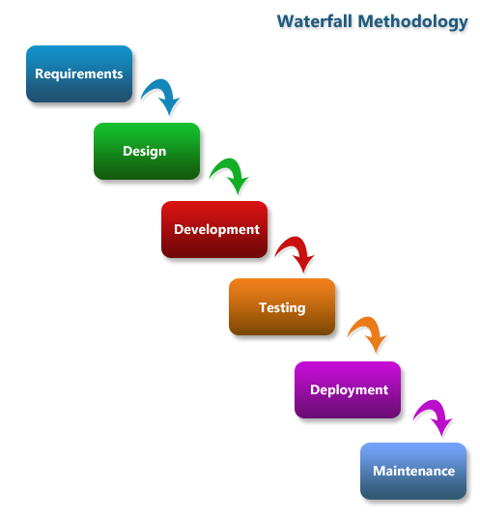

Figure 3‑1 Waterfall Methodology

*Source: Castellan Systems*

## 3.7 Testing plan for the system

The system shall be tested in different environments in order to test its functionality and accuracy. For this purpose, the system will be tested in an environment where the soil lacks enough water content and the water supply is short. By doing this, the accuracy of the system can be brought out. This will assure the users that all the specification goals are met.

The following table shows the test that will be conducted:

|  |  |  |
| --- | --- | --- |
| **Input** | **Expected actions (Processes)** | **Output** |
| Login Type | Three Types:  Administrator, editor and User Only | Administrator privileges, editor privileges and user privileges. |
| Login Validation | Username and password are set by the user | Validation check e.g.  Correct password: Login to the system  Incorrect password: Login error |
| Registration of new user | User completes all the required fields and submits the details. | New username and password allows the user to login. Incorrect details bring an error for failed login. |
| Administrator updating user  details | The administration can change or delete the details of the user | Password changed to a new  one and accepts login  The previous one invalid |
| Administration looking at the user list | The list of users can be viewed by the administrator | Details of the user i.e. status, mobile phone, day created can be viewed |

Table 3‑1 Testing Plan for the system

## 3.8 Ethical clearance considerations

For this research to go take place, ethical clearance from the following institutions is important:

* NACOST (National commission for science, technology and innovation)
* NEMA: National Environment Management Authority

# CHAPTER FOUR: SYSTEMS ANALYSIS AND SYSTEM DESIGN

## 4.0 Introduction

System analysis describes what a particular system should do in order to meet the information needs of a user whereas system design specifies how the system will accomplish these objectives. The above definitions briefly summarize the techniques that I will use to come up with a complete system meeting the needs of all the users. This chapter will cover the system requirements which cover functional requirements, non - functional requirements, stakeholders and design constraints. System modules consist of the use case diagrams, class diagrams, data flow diagrams and the entity relationship diagram.

## 4.1 System Requirements

System requirements are the configuration that a system must have in order for a hardware or software application to run smoothly and efficiently A requirement is condition or capability that must be met or possessed by a system or system component to satisfy a contract, standard, specification, or other formally imposed documents (Loucopoulos, 1995). For this system, the system requirements are functional requirements, non-functional requirements, stakeholders and the design constraints.

### 4.1.1 Functional Requirements

Functional requirements is a description of the service that the software must offer or in short describe the behavior of the system. It describes a software system or its components. Functional requirements describe functionality or system services. They depend on the type of software, expected users and the type of system where the software is used.

The functional requirement of the system are:

* The system will allow users to register or log in.
* The system will store and transfer data.
* The user will receive alerts if the system is not working.
* The system will measure the soil moisture and water level of the environment
* The system will allow the administrator to edit, update and delete user details

### 4.1.2 Non - Functional Requirements

Nonfunctional requirements define system attributes such as security, reliability, performance, maintainability, scalability, and usability. In short, they are not directly concerned with the specific services delivered by the system to its user.

The non-functional requirements of the system are:

* The system will be portable
* The system will accommodate only one farm/garden at a time
* The system will be connected to an external database
* The system should allow the administrator to view the user’s details.
* The system should run on any browser
* For physical security, this system will be placed in an environment where only the farmer/gardener and their authorized workers will have access.
* To access information, the user will have to enter a password to access the data.

## 4.3 Stakeholders

The stakeholders of this project are urban farmers, gardeners, local restaurant owners, the National Environmental Authority, the county government of Nairobi and other IoT developers.

## 4.4 System Models

### 4.4.1 Systems Architecture

The system consists of Arduino Uno, breadboard, LEDs, alarm, LCD, jump wires, capacitive soil moisture and water level sensor. All of these components have been integrated in order to achieve the design of a smart irrigation system. The figure below shows how these components are connected and how the system will look like.

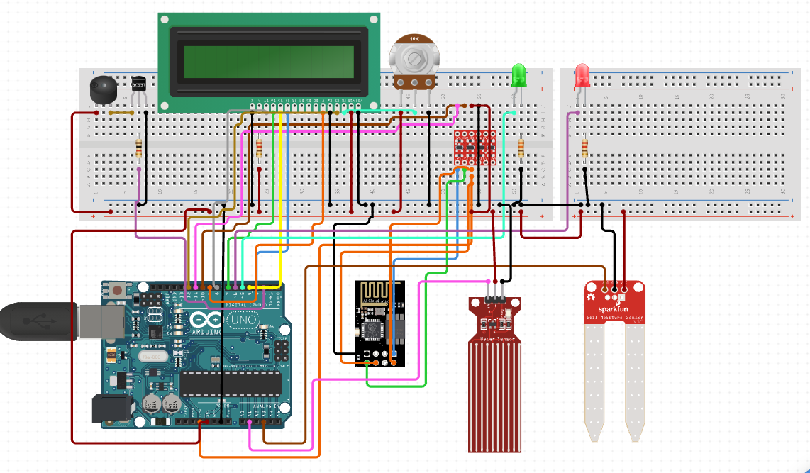

Figure 4‑1 Arduino Architecture

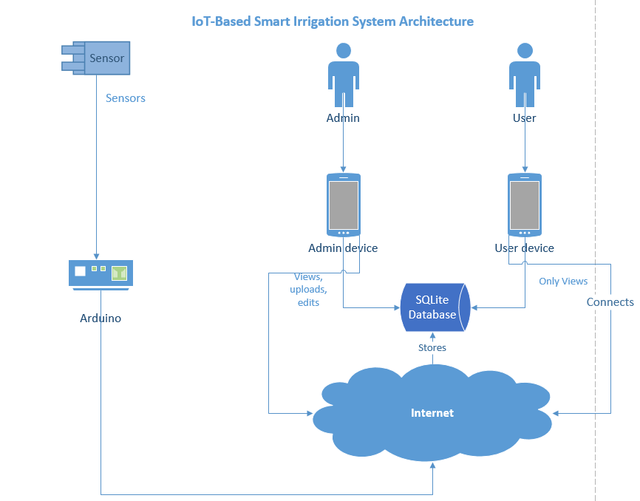

Figure 4‑2 IoT Based Smart Irrigation System Architecture

### 4.4.2 Use Case Diagram

Use case diagrams are a part of the UML (Unified Modeling Language) which is a widely used method of visualizing and documenting software systems design. A use case diagram visually represents the interaction between users and the information system. In a use case diagram, the user becomes an actor, with a specific role that describes how he or she interacts with the system.

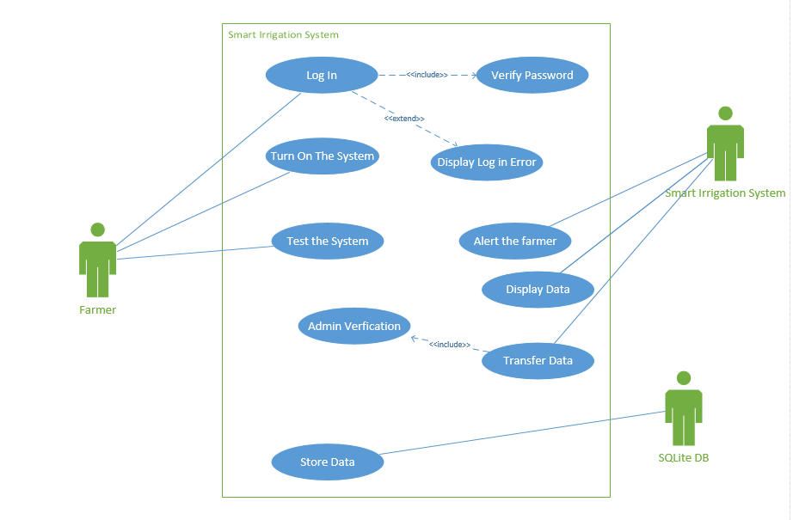

Figure 4‑3 Use Case Diagram

### 4.4.3 Flow chart

A flowchart is a type of diagram that represents a workflow or process. A flowchart can also be defined as a diagrammatic representation of an algorithm, a step-by-step approach to solving a task.

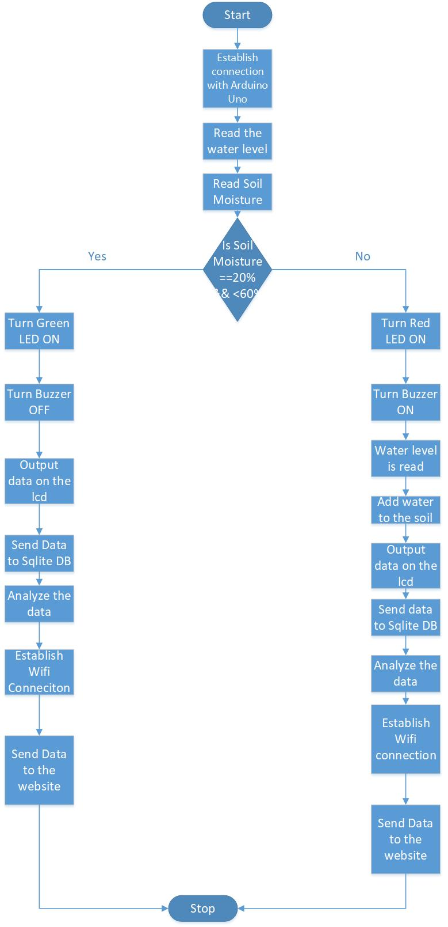

Figure 4‑4 Flowchart Diagram

### 4.4.4 Class Diagrams

Class diagrams are also a part of the Unified Modeling Language. They document the classes and relationships involved in individual use cases. Class diagrams evolve into code modules, data objects and other system components.

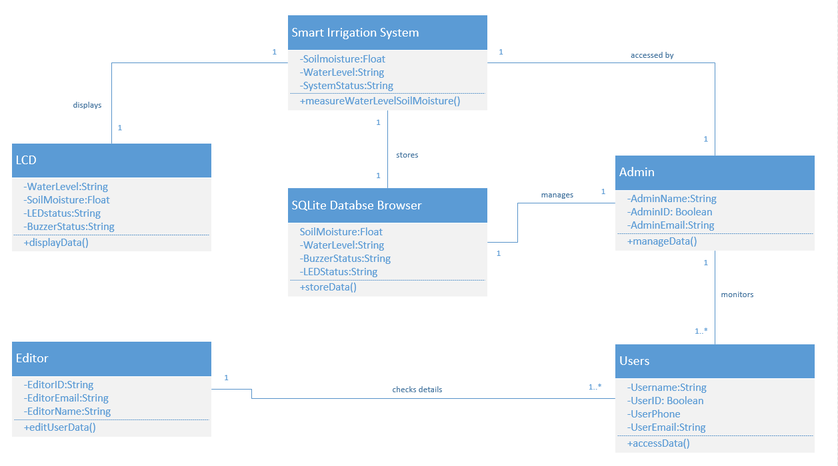

Figure 4‑5 Class Diagram

### 4.4.5 Data Flow Diagram

A data flow diagram shows the way information flows through a process or system. It includes data inputs and outputs, data stores, and the various sub processes the data moves through.

#### 4.4.5.1 Context Diagram 0

This is a basic overview of the whole system or process being analyzed or modeled. It's designed to be an at-a-glance view, showing the system as a single high-level process, with its relationship to external entities.

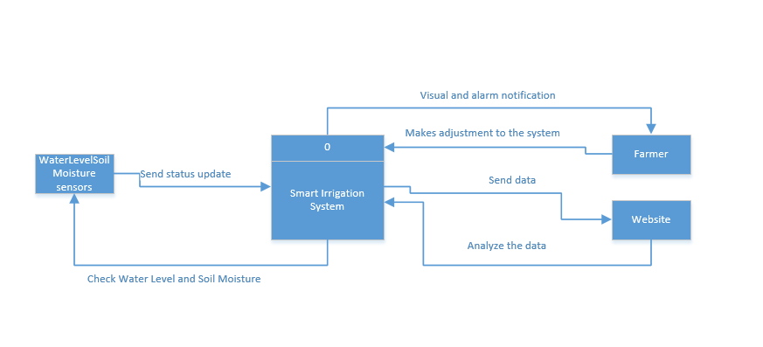

Figure 4‑6 Context Diagram 0

#### 4.4.5.2 Level 1 Diagram

A level 1 data flow diagram highlights main functions of a system. Visualize incoming data flow, processes and output data flows.

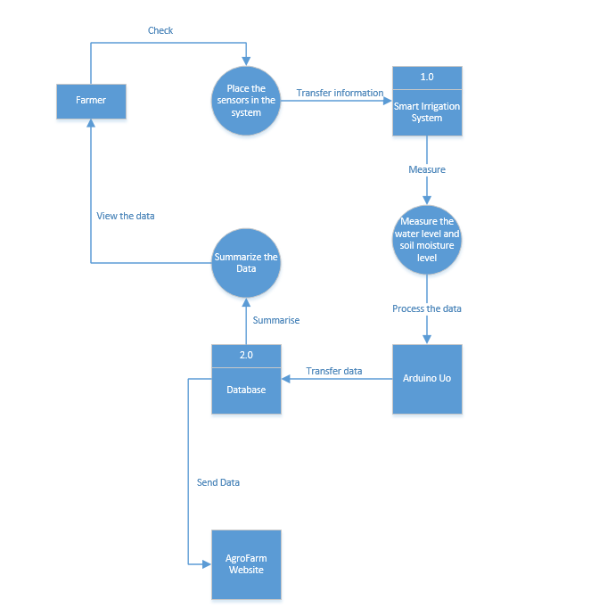

Figure 4‑7 Level 1 Diagram

#### 4.4.5.3 Level 2 Diagram

A level 2 data flow diagram (DFD) offers a more detailed look at the processes that make up an information system than a level 1 DFD does. It can be used to plan or record the specific makeup of a system. You can then input the particulars of your own system

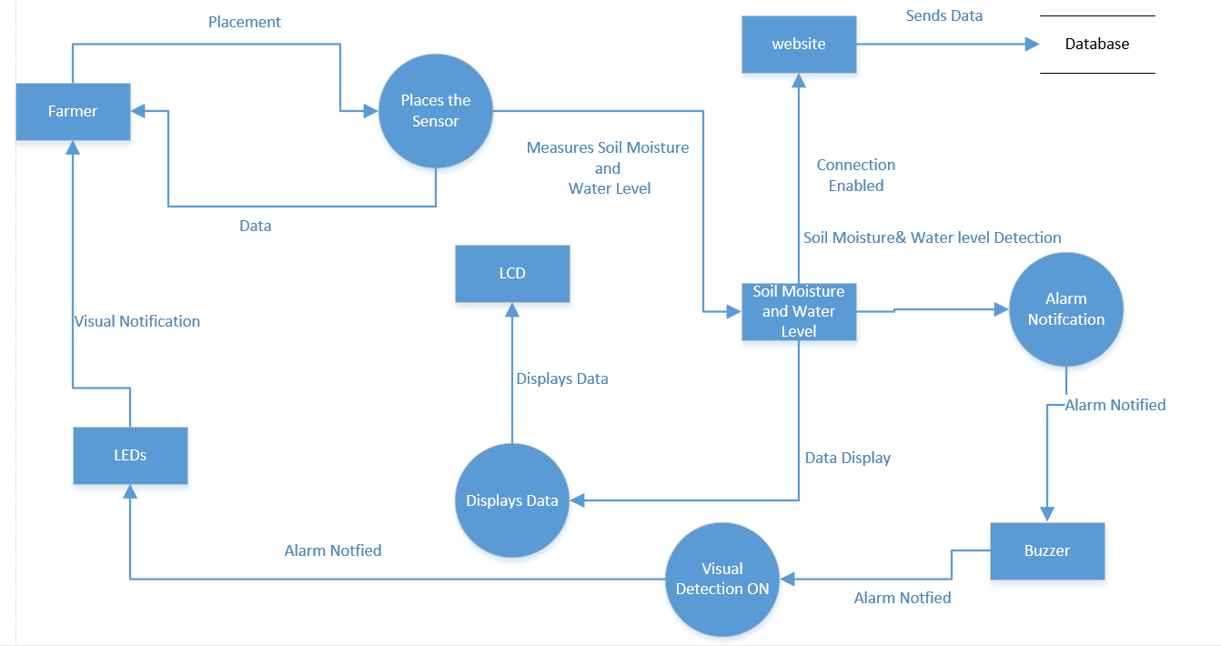

Figure 4‑8 Level 2 Diagram

### 4.4.6 Entity Relationship Diagram

An entity relationship diagram is a model that shows the logical relationships and the interaction among system entities. ER diagrams are related to data structure diagrams (DSDs), which focus on the relationships of elements within entities instead of relationships between entities themselves.

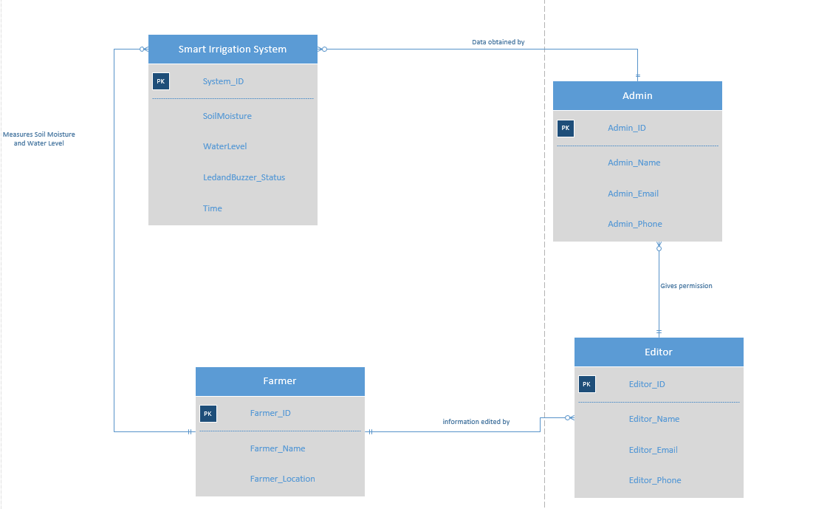

Figure 4‑9 Entity Relationship Diagram

### 4.4.7 Sequence Diagram

Sequence diagrams describe interactions among classes in terms of an exchange of messages over time. A sequence diagram consists of a group of objects that are represented by lifelines, and the messages that they exchange over time during the interaction.

#### 4.4.7.1 Admin Sequence Diagram

The figure below shows the admin sequence diagram. The admin should login to the system in order to have all the necessary admin privileges. The admin can delete or ignore reported reviews where changes are automatically updated on the main website. The admin can also create, edit or delete events from the main website.

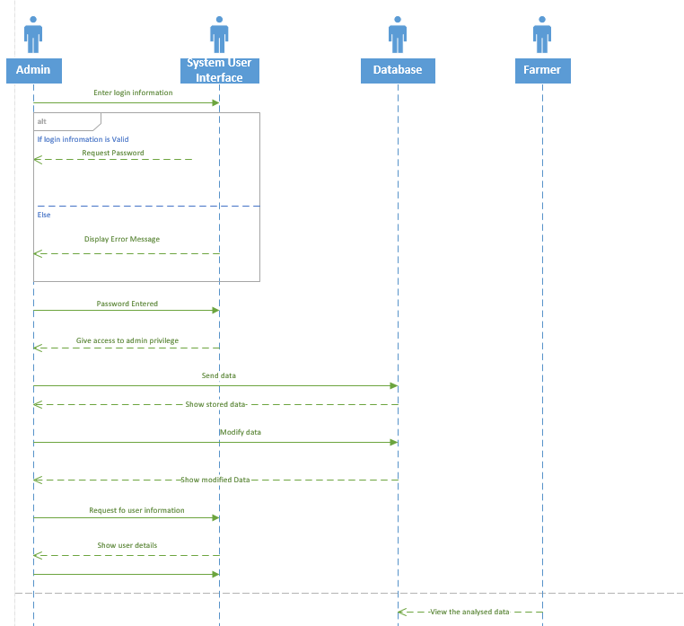

Figure 4‑10 Admin Sequence Diagram

#### 4.4.7.2 User Sequence Diagram

The figure bellows shows the user sequence. The user is to log in, reset passwords, view their data and data obtained from the system.

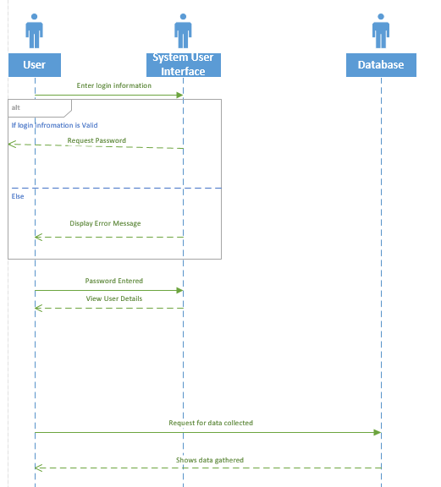

Figure 4‑11 User Sequence Diagram